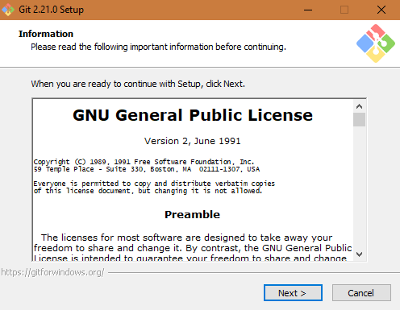

CLICK NEXT.

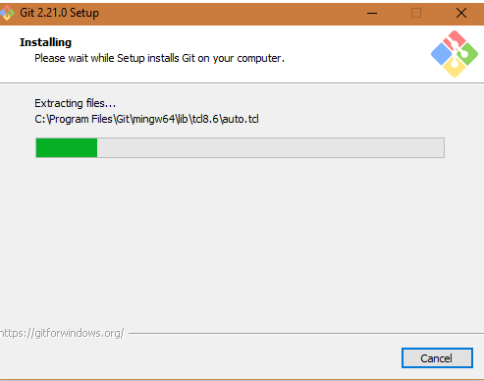

CLOOSE THE DEFAULT OPTION UNTIL FINISH.

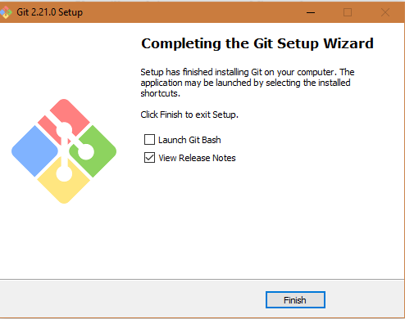

THEN WILL OPEN GIT BASH TERMINAL

